Wheelchairs
  - Portable lightweight chairs
    - Transport chair
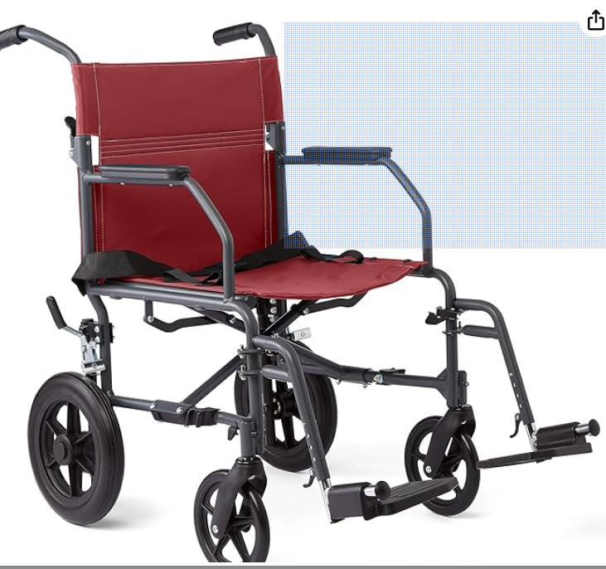

Push chair. Useful for travel and going to restaurants or around town.

    - Electric chair:
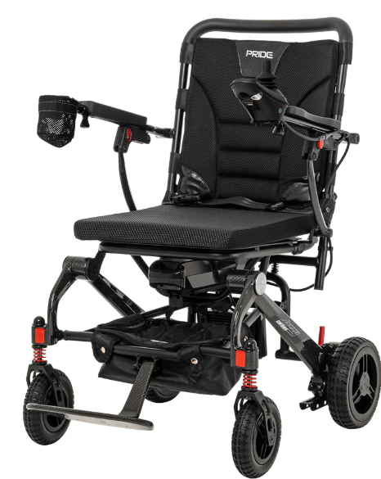

Electric chair: There are many different chairs available with different weights and functions. Tip: go to a medical supply store and try the different chairs before you buy one. Note- these chairs are not covered by insurance and can be quite expensive.

Customized Electric Chairs: Work with your healthcare providers with this when you are ready.

